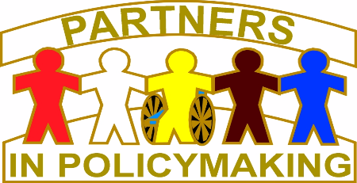

Partners online – Application Form

A course for people who want to influence services
and support for disabled people.

The course is open to disabled adults, Parents and relatives of disabled children and adults, and the people who support them through their work in health, education, and social care.

Dates for Partners online sessions

7th September 2022
14th September 2022
28th September 2022
12th October 2022
26th October 2022
9th November 2022
23rd November 2022
7th December 2022
14th December 2022

Plus 3 evening sessions with: John O’Brien,
Jack Pearpoint, Lynda Kahn and Patti Scott

The course aims are to enable participants:

- to make informed decisions on the resources needed for disabled people and their families to live a good life.
- to contribute to policymaking and service development
- to have the confidence and competence to influence decisions about services and support
- to support and guide other families.

Partners online
Application Form

Please answer the following questions. You can do this in whatever way is easiest for you.

Name:____________________________

Address:___________________________

Telephone No:______________________

Email address________________________

Do you have a child or young person with a disability?

Yes No

How old are they___________

Can you please tell us how their disability affects them
________________________________________________________________________________________________________________________

Are you an adult with a disability?
yes No

Can you tell us how your disability affects you
__________________________________________________________________________________________________________________

Do you work in services that support people with disabilities?

Can you tell us something about the work you do
______________________________________________________________________________________________________________________________

Can you tell us a bit more about yourself and your family
__________________________________________
__________________________________________
____________________________________________________________________________________

Why do you want to do Partners online course?
__________________________________________
____________________________________________________________________________________

What do you think the course will help you with the most? ____________________________________________________________________________________
__________________________________________

Can you tell us three qualities your family and friends would say you have. __________________________________________
__________________________________________

The online course will be held on Zoom. Do you need help using online technology?
__________________________________________

CLOSING DATE for applications is 30th June 2022.

Please submit your application form to:
admin@in-control.org.uk
or post it to:
In Control Partnerships
PO Box 17649
Solihull
B90 9LA

For further information contact;

Wendy Kellett or Gaynor Cockayne at:
Email - admin@in-control.org.uk
or telephone 0121 474 5900

